FREDERICK DOUGLASS ACADEMY VI
PARENT NEWSLETTER, December 2022 3rd EDITION
Principal Greetings

FDA VI Events
Nov. 30 PTA 6pm, Title 1-7pm, SLT 4pm
Dec. 3 Saturday School
Dec. 6 Progress Reports Distributed
Dec. 8 College & Career Fair 9am-11:30am
Dec. 10 Saturday School
Dec. 13 Free Immigration Clinic
Dec. 14 Financial Aid Night 4:30-6:30pm
Dec. 15 Dream Act/Fin.Aid Night 4:30-6:30pm
Dec. 17 Saturday School
Dec. 21 PTA 6pm, Title 1-7pm, SLT 4pm
Dec. 21 Report Card Distribution
Dec. 23 Ugly Sweater Holiday Show –(Aud)
Dec. 26 Winter Break Dec 26th –Jan 2nd
Jan. 3 School Resumes
All Parent Meetings are virtual
Find the links in your email!
Immigration Workshop
12/13/22
An Immigration workshop will be presented
Use the link below to join
Tuesday, December 13 at 5pm
Use the link below to join!

Microsoft Teams meeting
Join on your computer, mobile app or room device
Click here to join the meeting
Meeting ID: 244 252 841 210
Passcode: SBevxY
Download Teams | Join on the web
Or call in (audio only)
+1 347-966-4114,,411661570# United States, New York City
Phone Conference ID: 411 661 570#
Find a local number | Reset PIN
Learn More | Meeting options

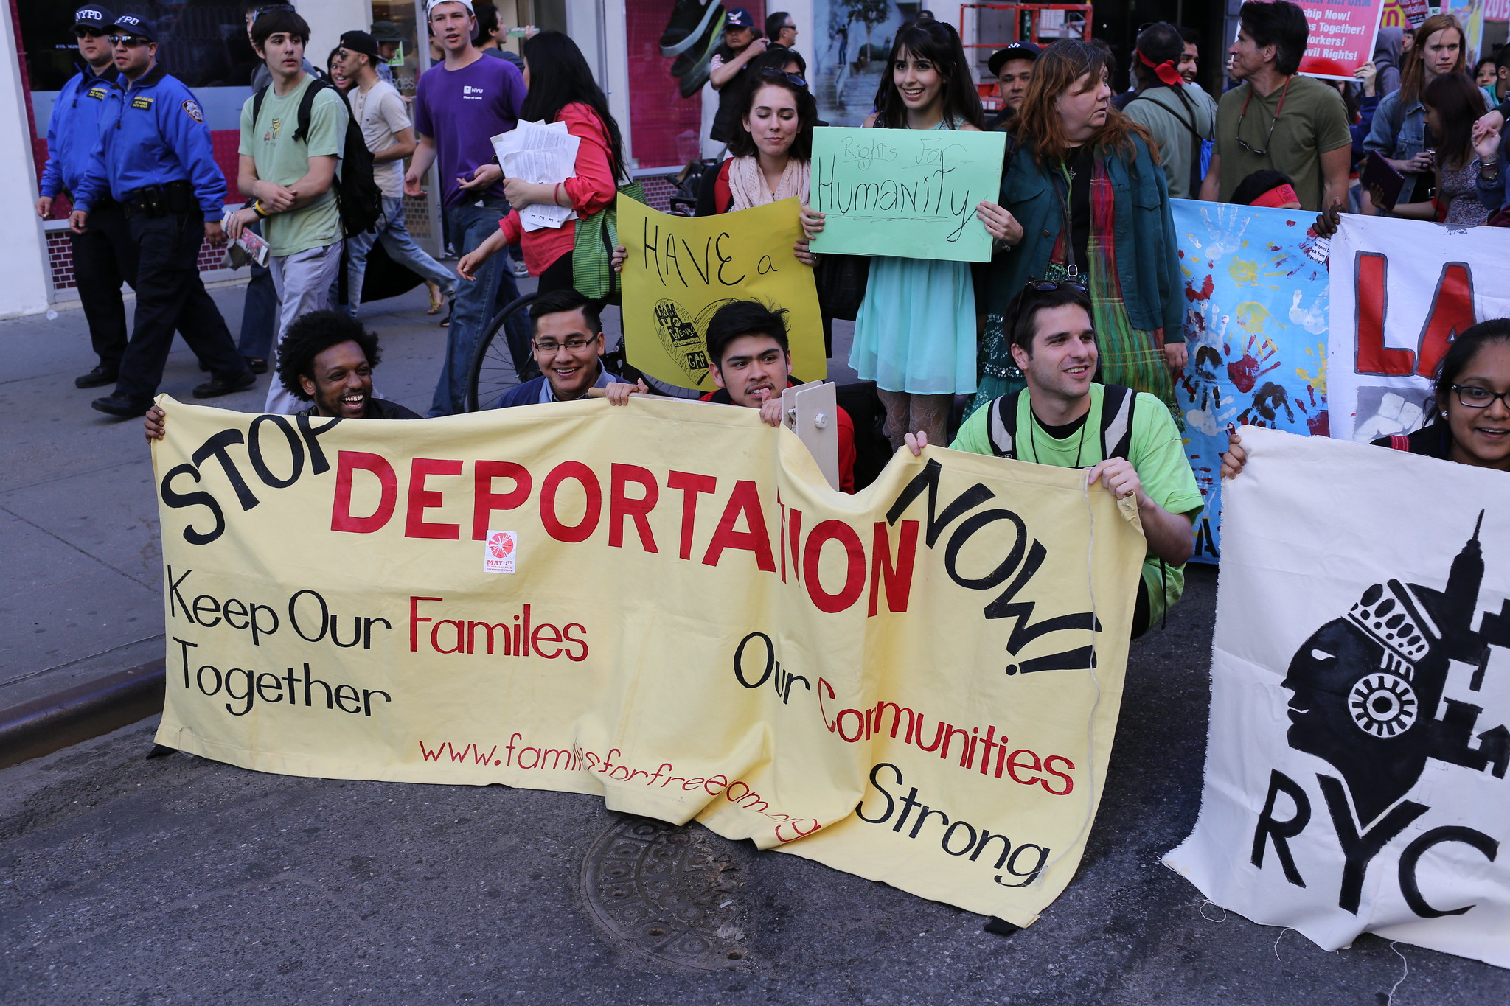

Greetings Parents,
Whew! So many great things are happening at FDA VI. Thanks to Child Center of NY
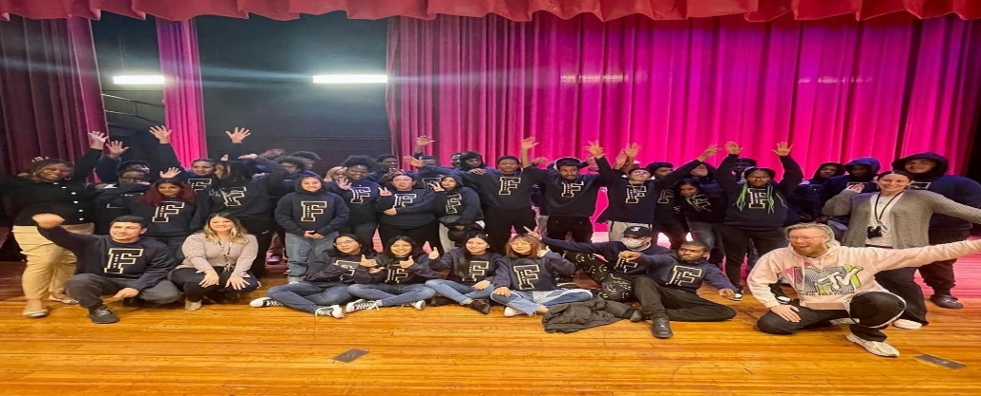
Some of our families received turkeys for Thanksgiving. We also celebrated as a family, sharing a catered meal together the day before Thanksgiving.The picture below is proof that we are a family who looks for reasons to celebrate our students. We honored students for attenedance and grades, with FDA VI sweaters! I would like you to know Saturday Regents Prep begins this Saturday, December 3. Please encourage your 10th-12th grader to attend 9am-12pm. We will help prepare our students for a great future with a College and Career Fair, December 8th, and follow up with two financial Aid nights, December 14th-15th with the 15th focusing upon the Dream Act. As we continuosly look for reasons to celebrate, we hope you celebrate the holidays with food, family, and friends. Mrs. Worley, Principal

Hello FDA VI Family,
FDA VI Parents, I just want to give a shout out to your dynamic parent leaders. The PTA Board, Ms. Dougal, Garcia, and Louis as well as Ms. Foerester, and Ms. Jones represent you and your voice. Get to know them! Join them at your December PTA, SLT
and Title 1 Meetings December 21st as they look out for you.
Thanks to Ms. Worley for providing an immigration attorney to assist parents. The attorney, Mr. Pinto, is personable and helpful. Please contact us if you’re in need of assistance. How can we help you? Please call or email me. I’m Ms. Roberts, your Parent Coordinator and I can be reached at 718-337-9550, 929 -617-5182 or email me at troberts@schools.nyc.gov.
PTA, Title 1, SLT December 21st, 2022
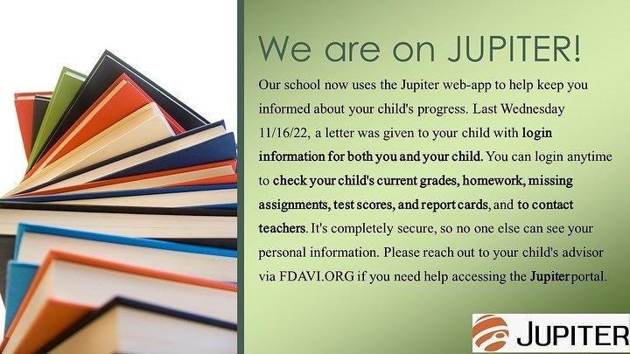
Did you sign up for JUPITER? You should have received a letter by mail with log in information.
In addition, a letter was given to your child with login information for you and your child. You can login any time to check your child’s current grades, homework, missing assignments, test scores and report cards, and you can contact teachers.

School Leadership Team Link, Wednesday, December 21 at 4pm
Microsoft Teams meeting
Join on your computer, mobile app or room device
Click here to join the meeting
Meeting ID: 265 094 993 017
Passcode: GMs2GE
Download Teams | Join on the web
Or call in (audio only)
+1 347-966-4114,,530161096# United States, New York City
Phone Conference ID: 530 161 096#
Find a local number | Reset PIN
Learn More | Meeting options

PTA & Title 1 Meeting Ling, Wednesday, December 21 at 6pm – 8pm
Microsoft Teams meeting
Join on your computer, mobile app or room device
Click here to join the meeting
Meeting ID: 284 772 586 023
Passcode: gw2JUG
Download Teams | Join on the web
Or call in (audio only)
+1 347-966-4114,,350882119# United States, New York City
Phone Conference ID: 350 882 119#
Find a local number | Reset PIN
Learn More | Meeting options

